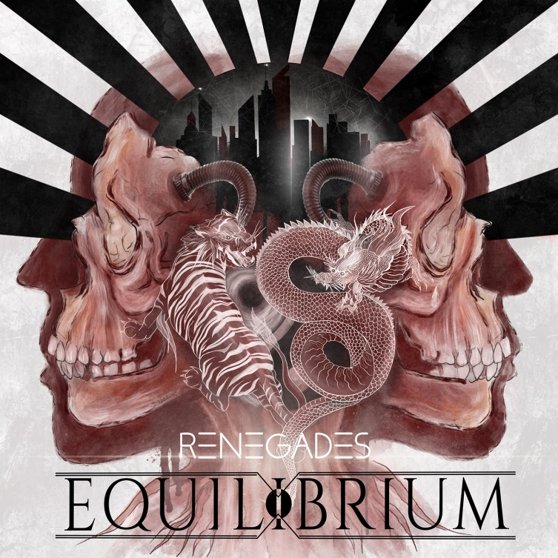

EQUILIBRIUM
»Renegades«

OUT: August 23rd, 2019

Lineup  Line up: | EQUILIBRIUM online:
Berthammer| Gitarre  Robse | Vocals  Skar | Clear Vocals  Skadi | Synths  Dom Crey | Gitarre  Hati | Schlagzeug | https://equilibrium-metal.net/band/  www.nuclearblast.de/equilibrium  https://de-de.facebook.com/equilibrium
Progress without estrangement is a rare craft that very few bands truly master. All too often, a band ventures so far from its roots it that loses its trademark sound. And every so often, a band’s stagnation drains all of its charm. Finding that rare balance between the two is a huge task not easily accomplished. And yet there is a band that has been coming close to that perfect balance more and more over the course of the past few years. A band that, ironically, already bears that balance in its well-known name: EQUILIBRIUM.

Born in 2001 in Southern Bavaria, the band has long become an Epic Metal powerhouse, a force to be reckoned with. Now, their latest, sixth record “Renegades” is heralding a watershed, the turn of an era for this genre. This could only happen because founder and guitar player René Berthiaume has been chasing his very own vision for 18 years now – more than half his life, actually! “I have never looked at it that way”, he marvels while he ponders this. “I always have to think of our first gig at Summer Breeze 2004. Some guy on the internet posted a comment after our show, saying that this band will disappear as quickly as it appeared. Well, what can I say? We’re still here!”

And stronger than ever, at that. This is not only because they broke the all too rigid chains of pagan metal – a feat they already pulled off with their last effort “Armageddon” (2016) storming to an impressive number five in the German album charts. No, this time around, “Renegades” shows a band unleashed, a band triumphantly marching to the very top. This is metal at its most epic and most monumental, bearing huge songs, resting firmly in the Zeitgeist with a massive, modern production and sporting quite a number of eclectic influences: Electronic elements, dystopian samples, Soundtrack grandeur, rock and roll energy and a rather surprising but very beguiling rap courtesy of Rapcore baddies Butcher Sisters. And before the bleating erupts: It’s working, it’s blending in - and above all, it’s still Equilibrium. Quite possibly more than ever.

“I have always had a very broad taste in music”, Berthiaume states, “thus we have been experimenting with Equilibrium from the very beginning.” This time around, however, it was less experimenting and more of an organic, liberating process of creation. “I confess that I fell into some kind of routine in some of our older songs. It took me a while to realize it.But from that moment on, I knew that I didn’t want to give routine even the slightest chance. I guess this is why I had so much fun doing this album!”

That was very important for the sole original member. Otherwise, he is declares quite honestly, the band wouldn’t be around any more. “There were times when I pondered the end of the band. Simply because I didn’t feel it any more. In the end, however, it was our incredible fans and our journeys round the globe that convinced me to carry on.” Equilibrium have always been known for their close ties with their loyal fan base. “Still, we have to remain true to ourselves in the first place”, he says. “I would never write a song to please others. Stagnation would be our death – and if the fans are willing to accept that, I couldn’t be happier!”

The step leading from “Armageddon” to “Renegades” may be a bit bigger than usual and also the world of legends, mythology and sagas has by now been entirely replaced by dark and personal themes; by urban legends and apocalyptic scenarios; for the band and for the whole genre, however, this album is a godsend. Bursting with energy, propelled forward by a newly-awakened fire and brimful with grand melodies, victorious choruses and a darkly throbbing energy, Equilibrium are redefining epic metal, making it viable in the process. “To accept change, to embrace or even initiate it is not always easy”, Berthiaume tells is. “But due to the fact that also my life back then was changing drastically, it was the perfect moment to just go with the flow and let the music do the talking.”

Born in the storm beaten solitude of the north, “Renegades” shows what this band is really capable of. “The band is made up of very different characters with individual strengths. Plus, we have two new members on board: Skar from Norway on clean vocals and live bass, Skadi, who has been working as a designer behind the scenes for quite some time now, as live keyboardist.” Written between September 2018 and March 2019, recorded in their private home studios, mixed by Robin Leijon in Sweden and mastered by Mike Kalajian in New York, this album is the purest essence of 18 years of Equilibrium. No more hiding behind myths and fairy tales, no more compromises, no more false modesty. Instead, “Renegades” is bringing in the harvest as a stellar, dark and breathtaking moment for German metal. “Its all about fear, desire and memory”, Berthiaume raps it all up. “About change, farewell and letting go. About mental health that should be addressed much more openly.” Ultimately, though, it’s also about the album title too. The renegades, the outlaws, the last gang in town: Equilibrium are back. They are stronger than ever, more confident than ever, more important than ever. And nothing will stop them now.

